**Coding Challenges 1.2**

1. **Write a program to arrange the given array in ascending order the array: a []={2,45,3,- 188,23}**

PROGRAM:

public class ascending{

public static void main(String[] args) {

int [] arr = new int [] {2,45,3,-188,23};

int temp = 0;

for (int i = 0; i < arr.length; i++) {

for (int j = i+1; j < arr.length; j++) {

if(arr[i] > arr[j]) {

temp = arr[i];

arr[i] = arr[j];

arr[j] = temp;

}

}

}

System.out.println("ascending order of the array: ");

for (int i = 0; i < arr.length; i++) {

System.out.print(arr[i] + " ");

}

}

}

**OUTPUT:**

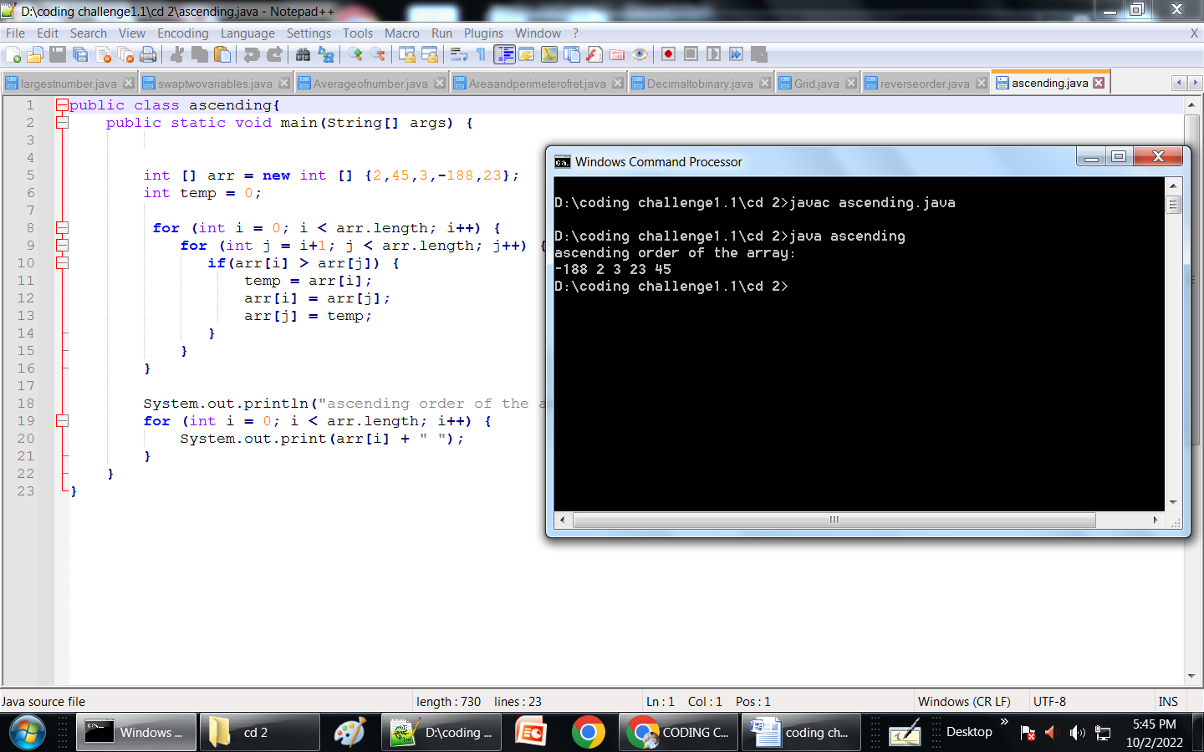

1. **write a java program to find nCr, where n and r values are given.**

**PROGRAM:**

import java.util.*;

class nCr {

static int nCr(int n, int r)

{

return fact(n) / (fact(r) * fact(n - r));

}

static int fact(int n)

{

int res = 1;

for (int i = 2; i <= n; i++)

res = res * i;

return res;

}

public static void main(String[] args)

{

int n,r;

System.out.println("Enter the value of n and r :");

Scanner sc = new Scanner(System.in);

n = sc.nextInt();

r = sc.nextInt();

System.out.println("nCr = "+nCr(n, r));

}

}

OUTPUT:

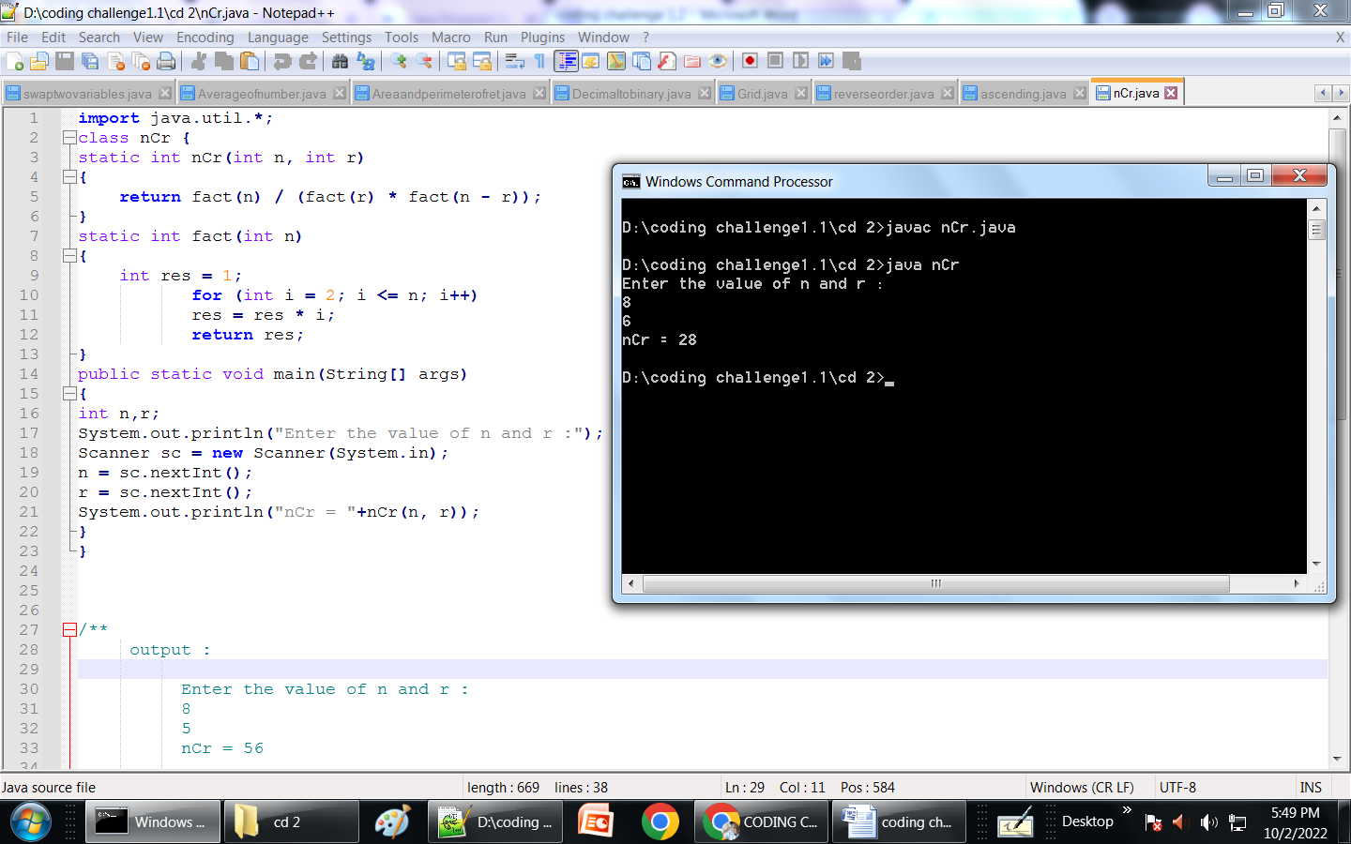

1. **Write a java program to swap to values without using another variable.**

**PROGRAM:**

import java.util.*;

class Swap_without_anothervariable

{

public static void main(String a[])

{

Scanner sc = new Scanner(System.in);

System.out.println("Enter the value of x ");

int x = sc.nextInt();

System.out.println("Enter the value of y");

int y = sc.nextInt();

x = x + y;

y = x - y;

x = x - y;

System.out.println("After swap: " +x +" , " + y);

}

}

**OUTPUT:**

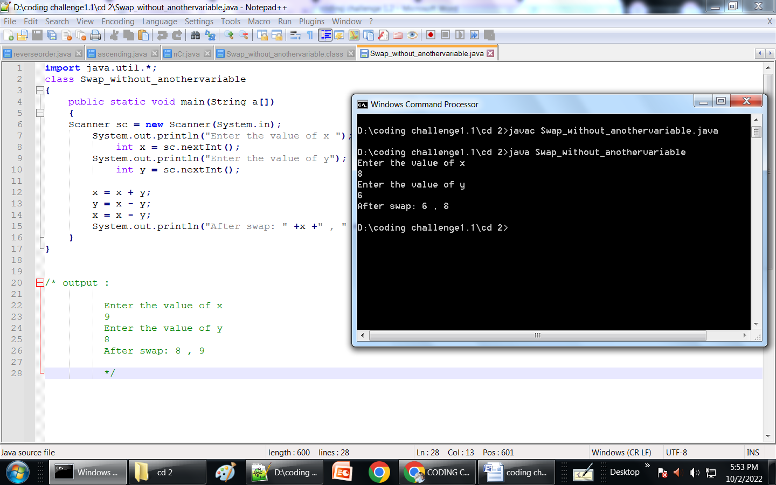

**4. In a program, if the array is final, each array element is multiplied by 10 and stored in the same array location. What is the result? Tell your opinion.**

**PROGRAM:**

import java.util.*;

class mulby10{

public static void main(String args[])

{

final int arr[] = { 1, 2, 3, 4, 5 };

for (int i = 0; i < arr.length; i++) {

arr[i] = arr[i] * 10;

System.out.println( + arr[i]);

}

}

}

**OUTPUT:**

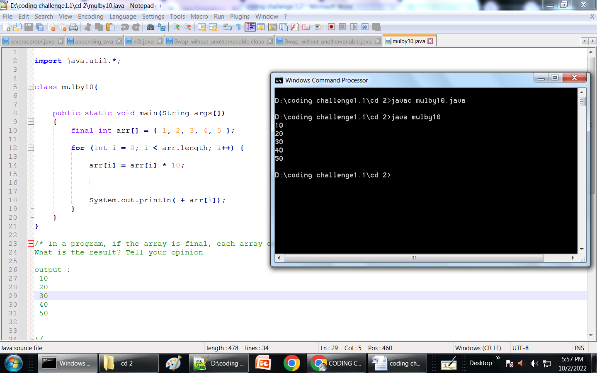

**5. Write the program to print the prime numbers between s to f.**

**PROGRAM:**

import java.util.*;

public class prime_num{

public static void main (String[]args)

{

Scanner sc = new Scanner(System.in);

System.out.print("Enter the value of s: ");

int s = sc.nextInt();

System.out.print("Enter the value of f: ");

int f = sc.nextInt();

System.out.println("prime numbers between s to f:");

for (int i = s; i <= f; i++)

if (isPrime (i))

System.out.println(i);

}

static boolean isPrime (int n)

{

int count = 0;

if (n < 2)

return false;

for (int i = 2; i < n; i++)

{

if (n % i == 0)

return false;

}

return true;

}

}

**OUTPUT:**

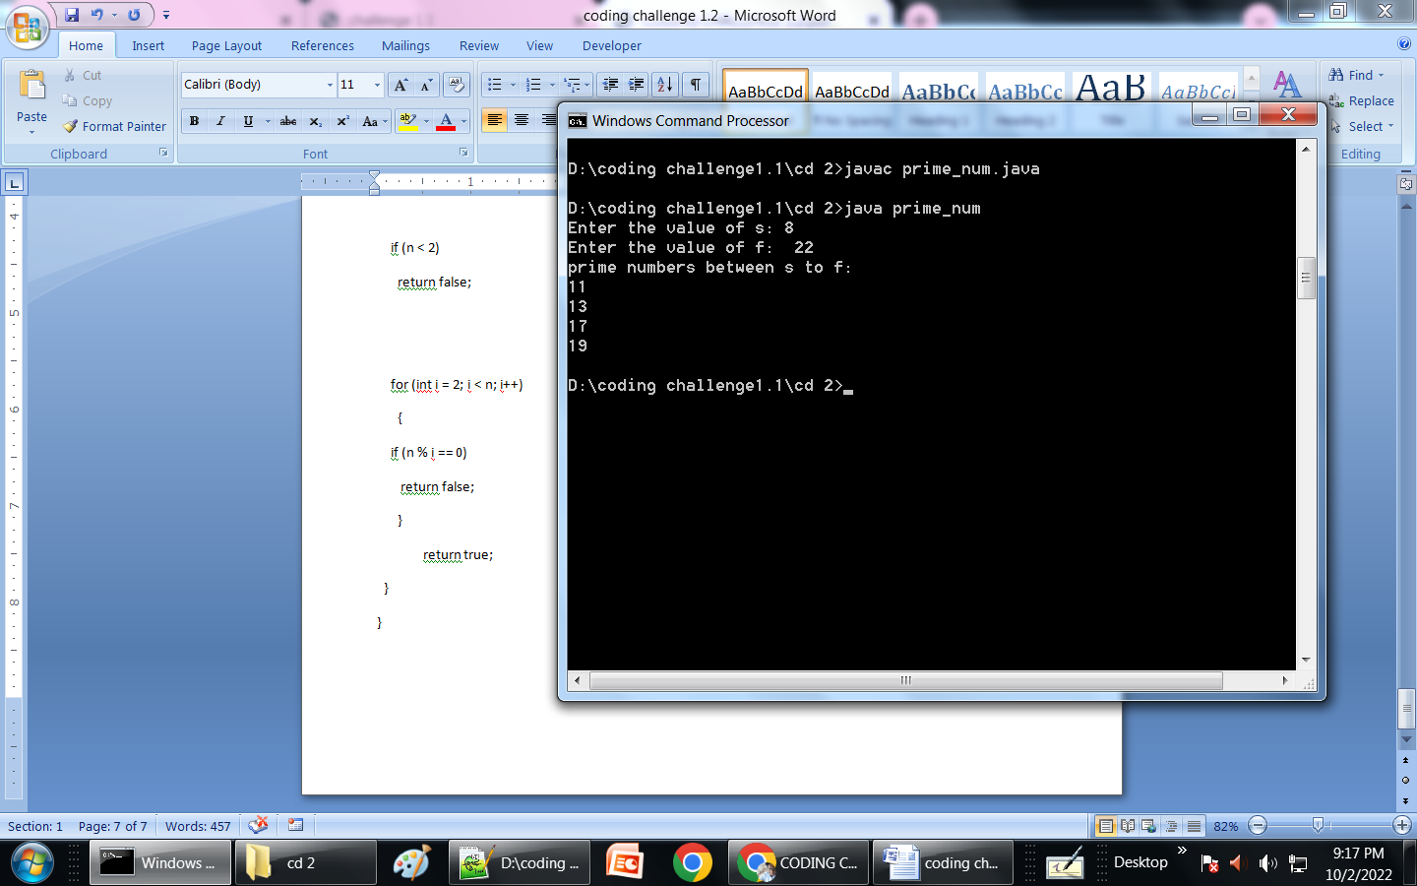

**6. Write a program which will accept a single pair of strings separated by a comma; the program should calculate the sum of ascii values of the characters of each string.**

**PROGRAM:**

import java.util.*;

public class sum_of_ascii

{

public static void main(String[] args)

{

Scanner sc = new Scanner(System.in);

System.out.print("enter the string:");

String str = sc.nextLine();

int sum=0;

for(int i=0; i<str.length(); i++)

{

int asciiValue = str.charAt(i);

sum = sum+ asciiValue;

}

System.out.println("sum of ASCII value of " + str +" is = "+ sum);

}

}

**OUTPUT:**

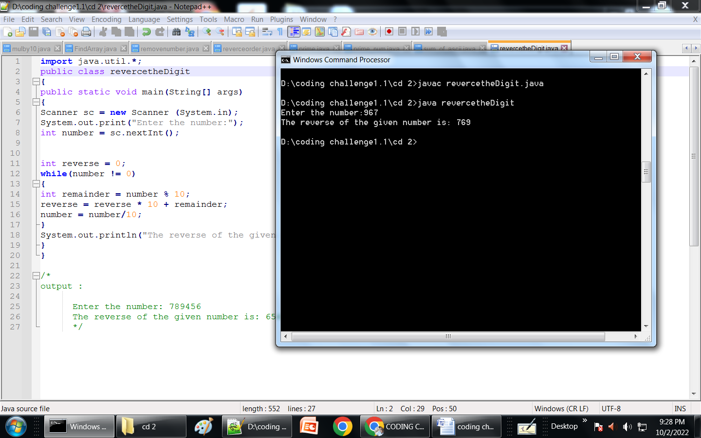

**7. Write a java program to reverse the digits of the given number like 967 is to be 769**

**PROGRAM:**

import java.util.*;

public class revercetheDigit

{

public static void main(String[] args)

{

Scanner sc = new Scanner (System.in);

System.out.print("Enter the number:");

int number = sc.nextInt();

int reverse = 0;

while(number != 0)

{

int remainder = number % 10;

reverse = reverse * 10 + remainder;

number = number/10;

}

System.out.println("The reverse of the given number is: " + reverse);

}

}

**OUTPUT:**

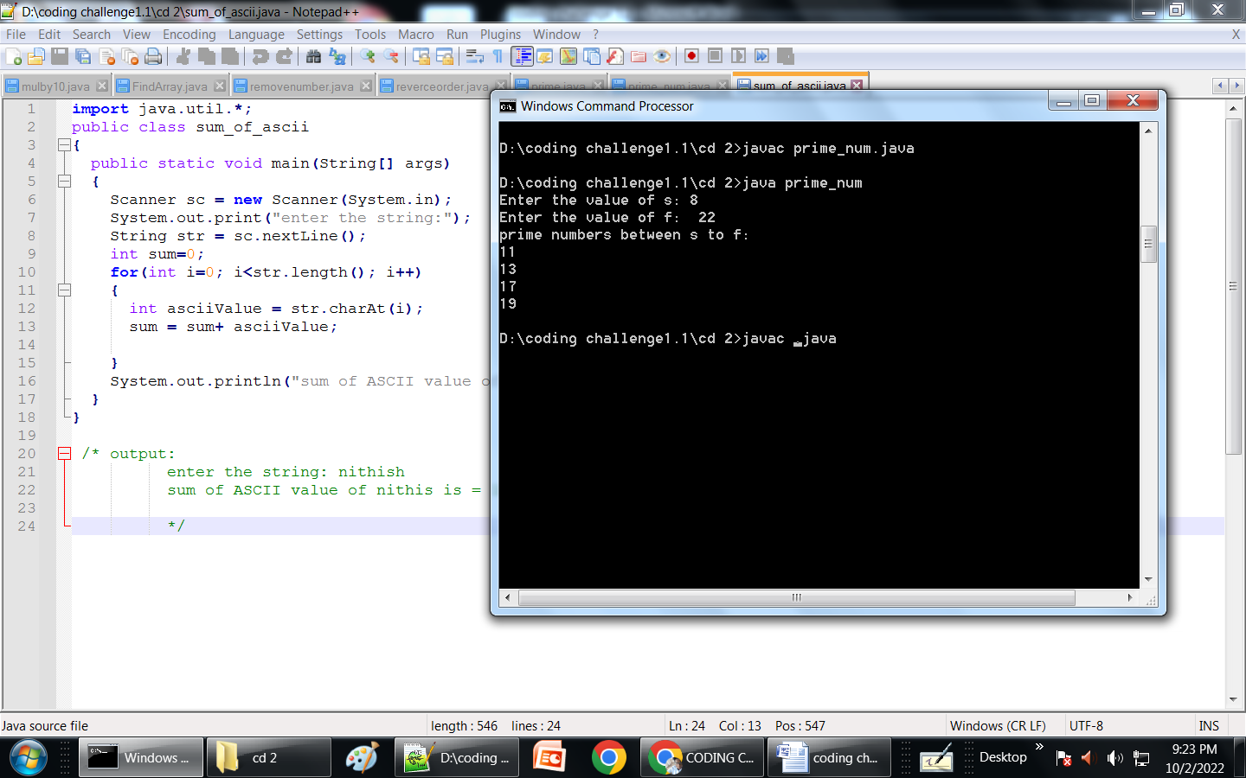

**8. Write the program to print the Armstrong numbers between 1 to n.**

**PROGRAM:**

import java.util.Scanner;

import java.lang.Math;

public class Amstrong_num

{

static boolean isArmstrong(int n)

{

int temp, digits=0, last=0, sum=0;

temp=n;

while(temp>0)

{

temp = temp/10;

digits++;

}

temp = n;

while(temp>0)

{

last = temp % 10;

sum += (Math.pow(last, digits));

temp = temp/10;

}

if(n==sum)

return true;

else return false;

}

public static void main(String args[])

{

int num;

Scanner sc= new Scanner(System.in);

System.out.print("Enter the n: ");

num=sc.nextInt();

System.out.println("Armstrong Number up to "+ num + " are: ");

for(int i=0; i<=num; i++)

if(isArmstrong(i))

System.out.print(i+ ", ");

}

}

**OUTPUT:**

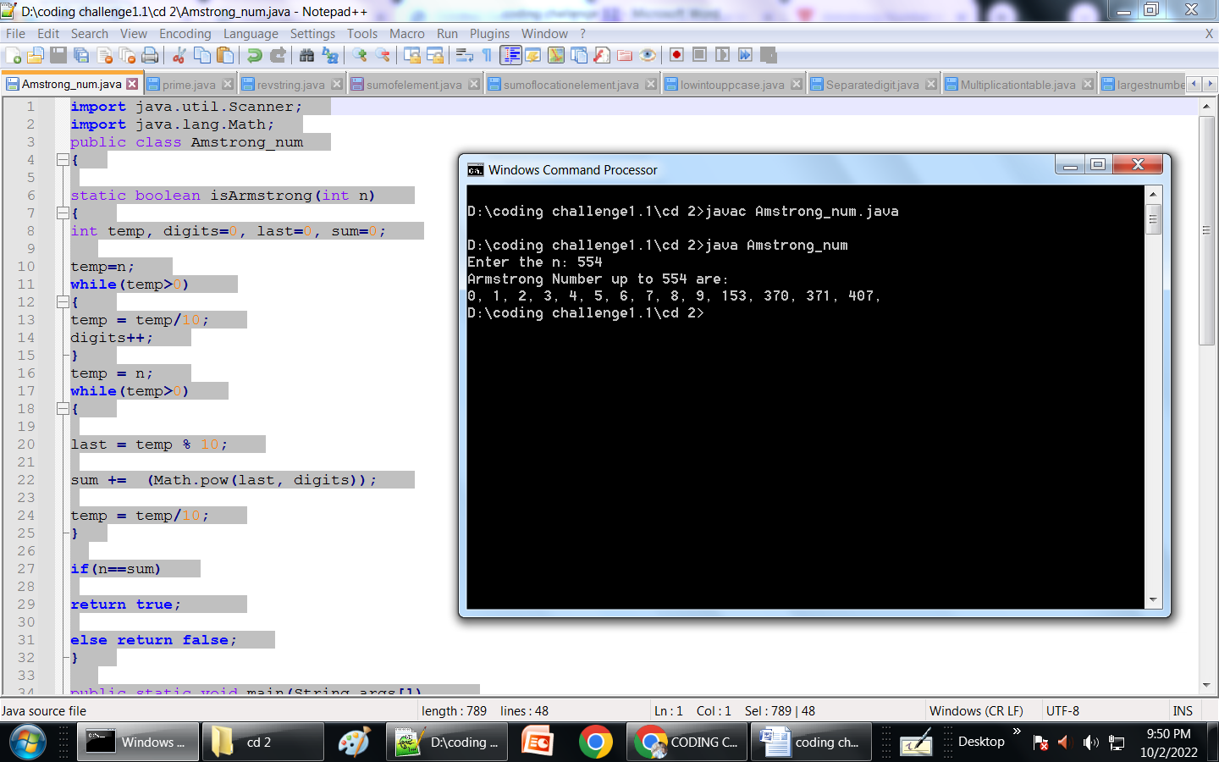

**9.Write the program to print Fibonacci series upto n.**

**PROGRAM:**

import java.util.*;

public class Fibonacci_series_n

{

public static void main (String[]args)

{

Scanner sc = new Scanner(System.in);

System.out.print("Enter the nth number :");

int n = sc.nextInt();

int a = 0, b = 1;

System.out.print (a + " , " + b + " , ");

int nextTerm;

for (int i = 2; i < n; i++)

{

nextTerm = a + b;

a = b;

b = nextTerm;

System.out.print (nextTerm + " , ");

}

}

}

**OUTPUT:**

